#1
Let P be any point P=(x₀.y₀) ≠ (0,0)
We can define E (T; P) = {L∩ T(L) : P ∈ L)
Suppose our point P in definition is O= (0,0) at the origin of the Cartesian plane, then, a line L through O is a figure that transforms T to E(T,O)
T(L) if y= mx is;
(ay-cx- aq + cp)= m(dx – by+ bq – dp)
Since (x₀,y₀) ≠ (0,0)
The above equation then gives;
m= (ay-cx-aq+cp) / (dx-by +bq – dp)
and now point (x,y) must satisfy ;
y= [(ay-cx-aq+cp)/ (dx-by +bq – dp)] x
equal to cx² +(d-a) xy –by² =(cp –aq)x + (dp – bq)y
which is our Cartesian equation.
E(T,P) is always an hyperbola if T reverses orientation
Δ< 0.
Δ= 4d- T² thus a hyperpola.
#2
E(T,P) is always an hyperbola if T reverses orientation
Δ< 0.
Δ= 4d- T² thus a hyperpola.
#2
Ax² + Bxy + Cy² + Dx + Ey + K = 0 (Cartesian relation for affine conics)
We need to define the affine type ( for definite Δ>0) as below
Δ= determinant = AC – ½ B2
This gives us 3 different conics ;
- parabola Δ=0
For (p, q) s.t f(p, q)= 0 the E(T,O) is degenerate which gives the line ;
(a-d)p + 2bq = 0 for bc0
2cp + (a-d)q = 0 for c≠ 0

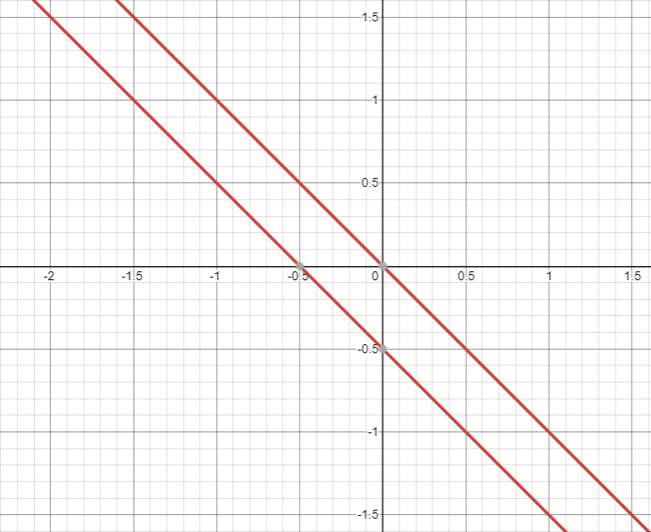

- Δ<0
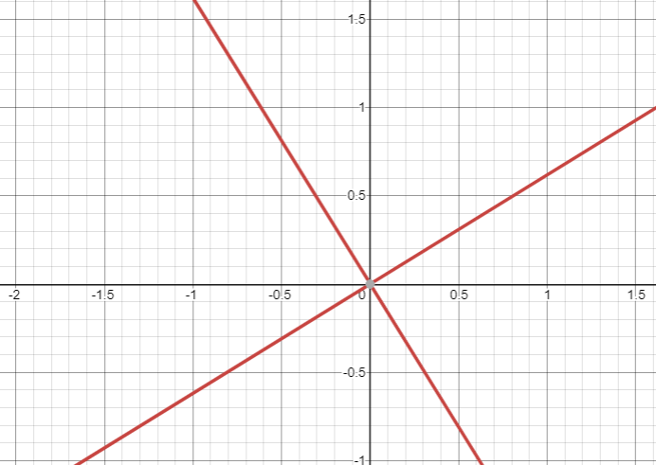

- Δ<0

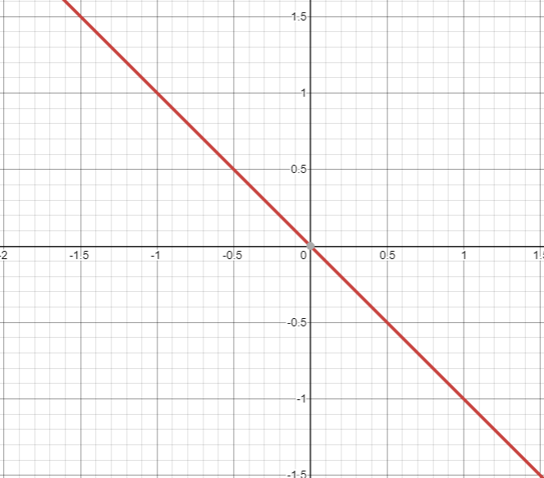

#3
ε= sin α/ sinβ
ε >1 for an hyperbola
(a-d ±√- Δ)p +2bq = 0, b≠0
p( cp + (d-a)q)=0, b=0
¼ p((5 ± √5)x ± 2√5y) is a degenerate hyperbola,
A conformal collineation T has a large eccentricity√2 and gives a hyperbola with perpendicular asymptotes.
Example of hyperbola with perpendicular asymptotes 9(1+x²) - 16y² =144
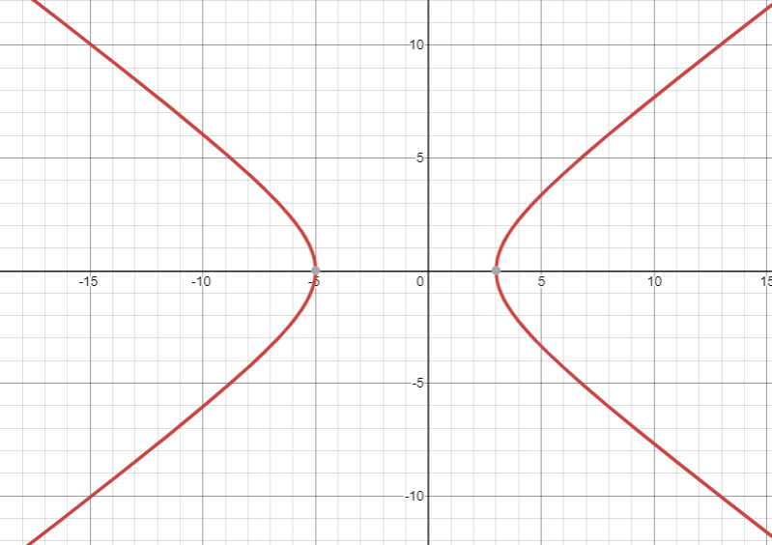

#4

